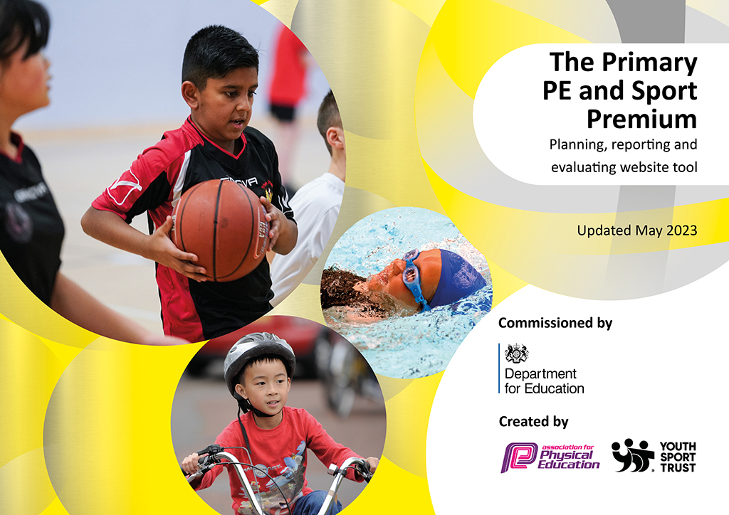
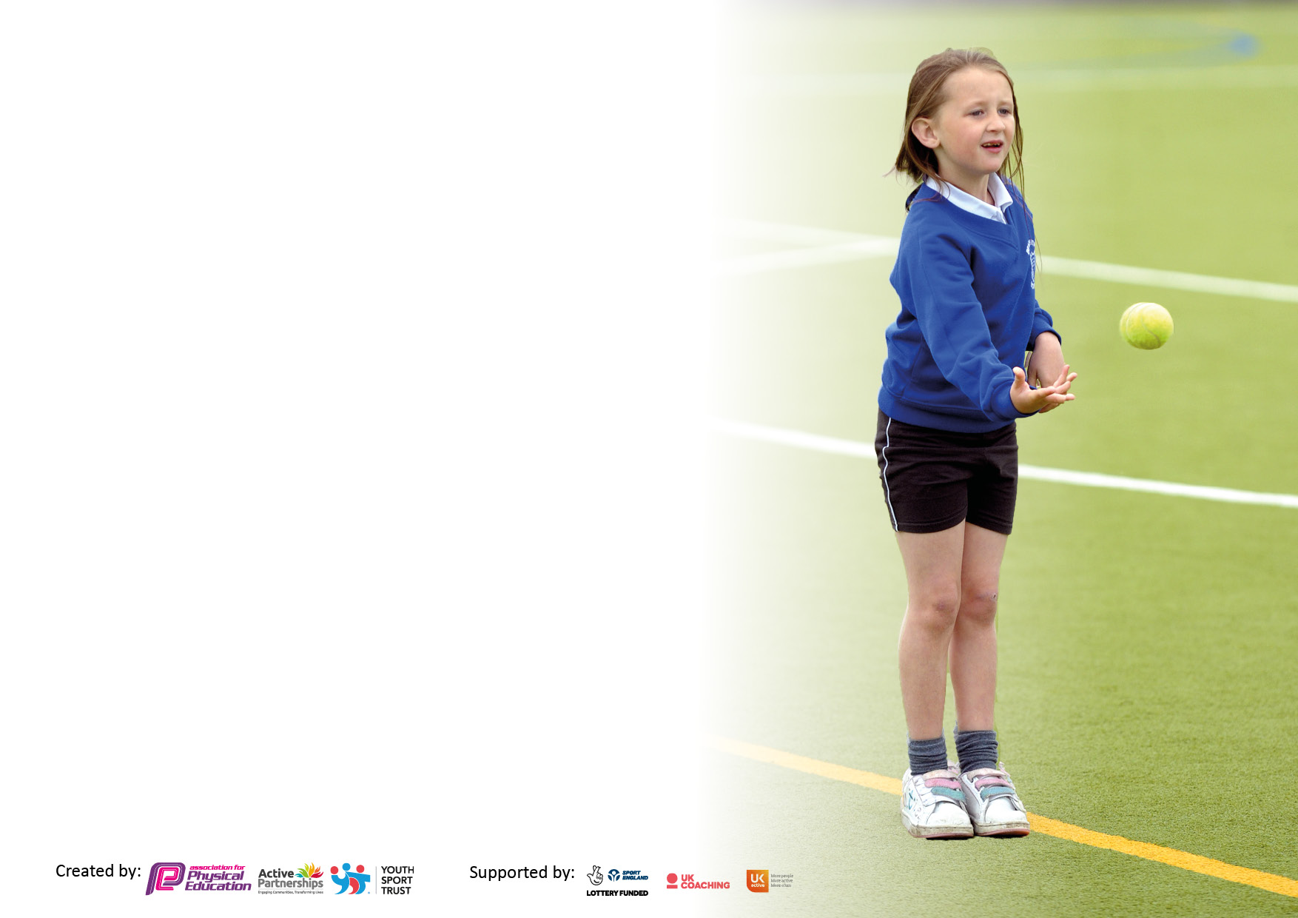

It is important that your grant is used effectively and based on school need. The Education Inspection Framework makes clear there will be a focus on ‘whether leaders and those responsible for governors all understand their respective roles and perform these in a way that enhances the effectiveness of the school’.

Under the Quality of Education Ofsted inspectors consider:
Intent - Curriculum design, coverage and appropriateness
Implementation - Curriculum delivery, Teaching (pedagogy) and Assessment
Impact - Attainment and progress

To assist schools with common transferable language this template has been developed to utilise the same three headings which should make your plans easily transferable between working documents.

Schools must use the funding to make additional and sustainable improvements to the quality of Physical Education, School Sport and Physical Activity (PESSPA) they offer. This means that you should use the Primary PE and sport premium to:

- Develop or add to the PESSPA activities that your school already offer
- Build capacity and capability within the school to ensure that improvements made now will benefit pupils joining the school in future years
- The Primary PE and sport premium should not be used to fund capital spend projects; the school’s budget should fund these.

Pleasevisitgov.ukfortherevisedDfEguidanceincludingthe5keyindicatorsacrosswhichschoolsshoulddemonstrate animprovement.Thisdocumentwillhelpyoutoreviewyourprovisionandtoreportyourspend.DfEencouragesschools to use this template as an effective way of meeting the reporting requirements of the Primary PE and Sport Premium.

We recommend you start by reflecting on the impact of current provision and reviewing the previous spend.

Schools are required to publish details of how they spend this funding, including any under-spend from 2021/2022, as well as on the impact it has on pupils’ PE and sport participation and attainment. All funding must be spent by 31st July 2023.

We recommend regularly updating the table and publishing it on your website throughout the year. This evidences your ongoing self-evaluation of how you are using the funding to secure maximum, sustainable impact. Final copy must be posted on your website by the end of the academic year and no later than the 31st July 2023. To see an example of how to complete the table please click HERE.

Details with regard to funding
Please complete the table below.

Total amount of funding for 2023/23. To be spent and reported on by 31st July 2023. | £ 17680
Swimming Data
Please report on your Swimming Data below.

Meeting national curriculum requirements for swimming and water safety.

N.B. Complete this section to your best ability. For example you might have practised safe self-rescue techniques on dry land which you can then transfer to the pool when school swimming restarts.
Due to exceptional circumstances priority should be given to ensuring that pupils can perform safe self rescue even if they do not fully meet the first two requirements of the NC programme of study
What percentage of your current Year 6 cohort swim competently, confidently and proficiently over a distance of at least 25 metres?  N.B. Even though your pupils may swim in another year please report on their attainment on leaving primary school at the end of the summer term 2022.  Please see note above | 87%
What percentage of your current Year 6 cohort use a range of strokes effectively [for example, front crawl, backstroke and breaststroke]?  Please see note above | 90%
What percentage of your current Year 6 cohort perform safe self-rescue in different water-based situations? | 97%
Schools can choose to use the Primary PE and sport premium to provide additional provision for swimming but this must be for activity over and above the national curriculum requirements. Have you used it in this way? | Yes, for SEND and pupil premium pupils.

Action Plan and Budget Tracking
Capture your intended annual spend against the 5 key indicators. Clarify the success criteria and evidence of impact that you intend to measure to evaluate for pupils today and for the future.

Academic Year: 2022/23 | Total fund allocated:£17680 | Date Updated:10.7.23
Key indicator 1: The engagement of all pupils in regular physical activity – Chief Medical Officers guidelines recommend that primary school pupils undertake at least 30 minutes of physical activity a day in school |  |  |  | Percentage of total allocation:
 |  |  |  | 55% (Sports Coaches)
Intent | Implementation |  | Impact
Your school focus should be clear what you want the pupils to know and be able to do and about  what they need to learn and to  consolidate through practice: | Make sure your actions to achieve are linked to your intentions: | Funding allocated: | Evidence of impact: what do pupils now know and what can they now do? What has changed?: | Sustainability and suggested next steps:
- Sessions with specialist sports coaches (Multiflex) in curriculum time for pupils across the school. Dance teaching was a particular focus to ensure that this teaching was excellent and progressive.  Using play leaders and sports council to develop our active 30 goal. Brain breaks during the day every 45 minutes and active break times using play leaders have ensured most pupils are active for 30 minutes. | Multiflex to deliver the teaching of dance sessions ensuring progressive, sequential teaching. | £9690 | The sports company’s dance specialist has been excellent at developing pupils’ knowledge and skills in dance. Children are engaged and enjoying the sessions while developing their skills too.  Play leaders are now able to lead active break times and this has ensured that most children across school are active for 30 minutes at school each day. | Engaging our reluctant PE learners in PE and extra-curricular activities.  Continuing to develop our dance curriculum.  Continuing to work with the Sports Council Ambassadors to develop active break times and monitor this to ensure this continues next year.
Key indicator 2: The profile of PESSPA being raised across the school as a tool for whole school improvement |  |  |  | Percentage of total allocation:
 |  |  |  | 4% (planning scheme)
Intent | Implementation |  | Impact
Your school focus should be clear what you want the pupils to know and be able to do and about  what they need to learn and to  consolidate through practice: | Make sure your actions to achieve are linked to your intentions: | Funding allocated: | Evidence of impact: what do pupils now know and what can they now do? What has changed?: | Sustainability and suggested next steps:
Ensuring the long term planning for PE is progressive and implementing and monitoring the new curriculum that has been designed this year using our new planning scheme Primary PE Planning. | Class teachers to teach PE using Primary PE Planning. | £695 | The new curriculum has been excellent- pupils’ knowledge and skills have really developed this year in gymnastics and in the different invasion and striking and fielding games. The curriculum, developed using our new planning scheme is progressive and sequential and is providing depth as well as breadth. | Continue to develop our curriculum including adding more sports for reluctant learners and providing more after school clubs to train for competitions and develop sport in school, as well as appealing to reluctant learners.

Key indicator 3: Increased confidence, knowledge and skills of all staff in teaching PE and sport |  |  |  | Percentage of total allocation:
 |  |  |  | 59% (55% Sports coaches +planning scheme)
Intent | Implementation |  | Impact
Your school focus should be clear | Make sure your actions to | Funding | Evidence of impact: what do | Sustainability and suggested
what you want the pupils to know | achieve are linked to your | allocated: | pupils now know and what | next steps:
and be able to do and about | intentions: |  | can they now do? What has
what they need to learn and to |  |  | changed?:
consolidate through practice:
Ensuring the long term planning for PE is progressive and implementing and monitoring the new curriculum that has been designed this year using our new planning scheme Primary PE Planning.  - Use sports coaches to develop our teaching of dance- Sessions with specialist sports coaches (Multiflex) in curriculum time for pupils across the school. Dance teaching was a particular focus to ensure that this teaching was excellent and progressive. Teachers and support staff have observed sessions to develop their knowledge and skills. | Class teachers to teach PE using Primary PE Planning. | £695  £9690 | The new curriculum has been excellent- pupils’ knowledge and skills have really developed this year in gymnastics and in the different invasion and striking and fielding games. The curriculum, developed using our new planning scheme is progressive and sequential and is providing depth as well as breadth.  Staff are more confident in what a good dance lesson looks like and how to achieve this. | Continue to develop our curriculum including adding more sports for reluctant learners and providing more after school clubs to train for competitions and develop sport in school, as well as appealing to reluctant learners.  Continue to develop staff confidence in teaching PE using the scheme of work and use of coaches.
Key indicator 4: Broader experience of a range of sports and activities offered to all pupils |  |  |  | Percentage of total allocation:
 |  |  |  | 35%
Intent | Implementation |  | Impact
Your school focus should be clear | Make sure your actions to | Funding | Evidence of impact: what do | Sustainability and suggested
what you want the pupils to know | achieve are linked to your | allocated: | pupils now know and what | next steps:
and be able to do and about | intentions: |  | can they now do? What has
what they need to learn and to |  |  | changed?:
consolidate through practice:
Pupils have had lots of opportunities in extra-curricular clubs this year with Sports Coaching Group, Multiflex and with school staff. As well as traditional sports, pupils have also had other opportunities such as fencing and lacrosse.  Provide additional provision for swimming over and above the national curriculum requirements. | Pupils have had lots of opportunities in extra-curricular clubs this year with Sports Coaching Group, Multiflex and with school staff. As well as traditional sports, pupils have also had other opportunities such as fencing and lacrosse.  Additional opportuniries for SEND and pupil premium pupils. | £1343  £4900 | Pupils have enjoyed after school clubs including new sports, although uptake hasn’t always been very high. | Try to increase the uptake of after school clubs and continue to provide opportunities for new sports, by offering a wider range of sports.

Key indicator 5: Increased participation in competitive sport |  |  |  | Percentage of total allocation:
 |  |  |  | 6%
Intent | Implementation |  | Impact
Your school focus should be clear | Make sure your actions to | Funding | Evidence of impact: what do | Sustainability and suggested
what you want the pupils to know | achieve are linked to your | allocated: | pupils now know and what | next steps:
and be able to do and about | intentions: |  | can they now do? What has
what they need to learn and to |  |  | changed?:
consolidate through practice:
Providing opportunities for all pupils to compete in sport, including SEND and gifted and talented pupils. | In our Holmes Chapel cluster competitions, we have taken part in 27 competitions (often taking two teams) as in previous years, which provide inter school opportunities for all pupils, made up of inclusive opportunities like Boccia, as well as highly competitive competitions for gifted and talented and other pupils. Events such as festivals and workshops have also appealed to more reluctant learners. | £1101 | Several Year 3 pupils have now been involved in competitive sport for the first time, while Year 4, 5 and 6 pupils have been able to practice and develop in further competitions, as well as competing in new events such as volleyball, dance and girls football events. | Work with Holmes Chapel Comprehensive School to continue to provide more opportunities to cater to more pupils such as festivals and inclusive events that may appeal to reluctant learners and SEND pupils.

Signed off by
Head Teacher:
Date:
Subject Leader: | A.McAulay
Date: | 10.7.23
Governor:
Date:

