Parents Meeting: Listening to your child read

What can you do to help at home?

- Listen to your child read the same Read Write Inc. Storybook again and again.
- Encourage them to use ’Special Friends’, ‘Fred Talk’, ‘read the word’.
- Discuss the story and encourage their storyteller voice.

There are free video tutorials on our website – www.ruthmiskin.com

Select ‘More and International’ at the top, then ‘Home reading’ from the drop-down list:

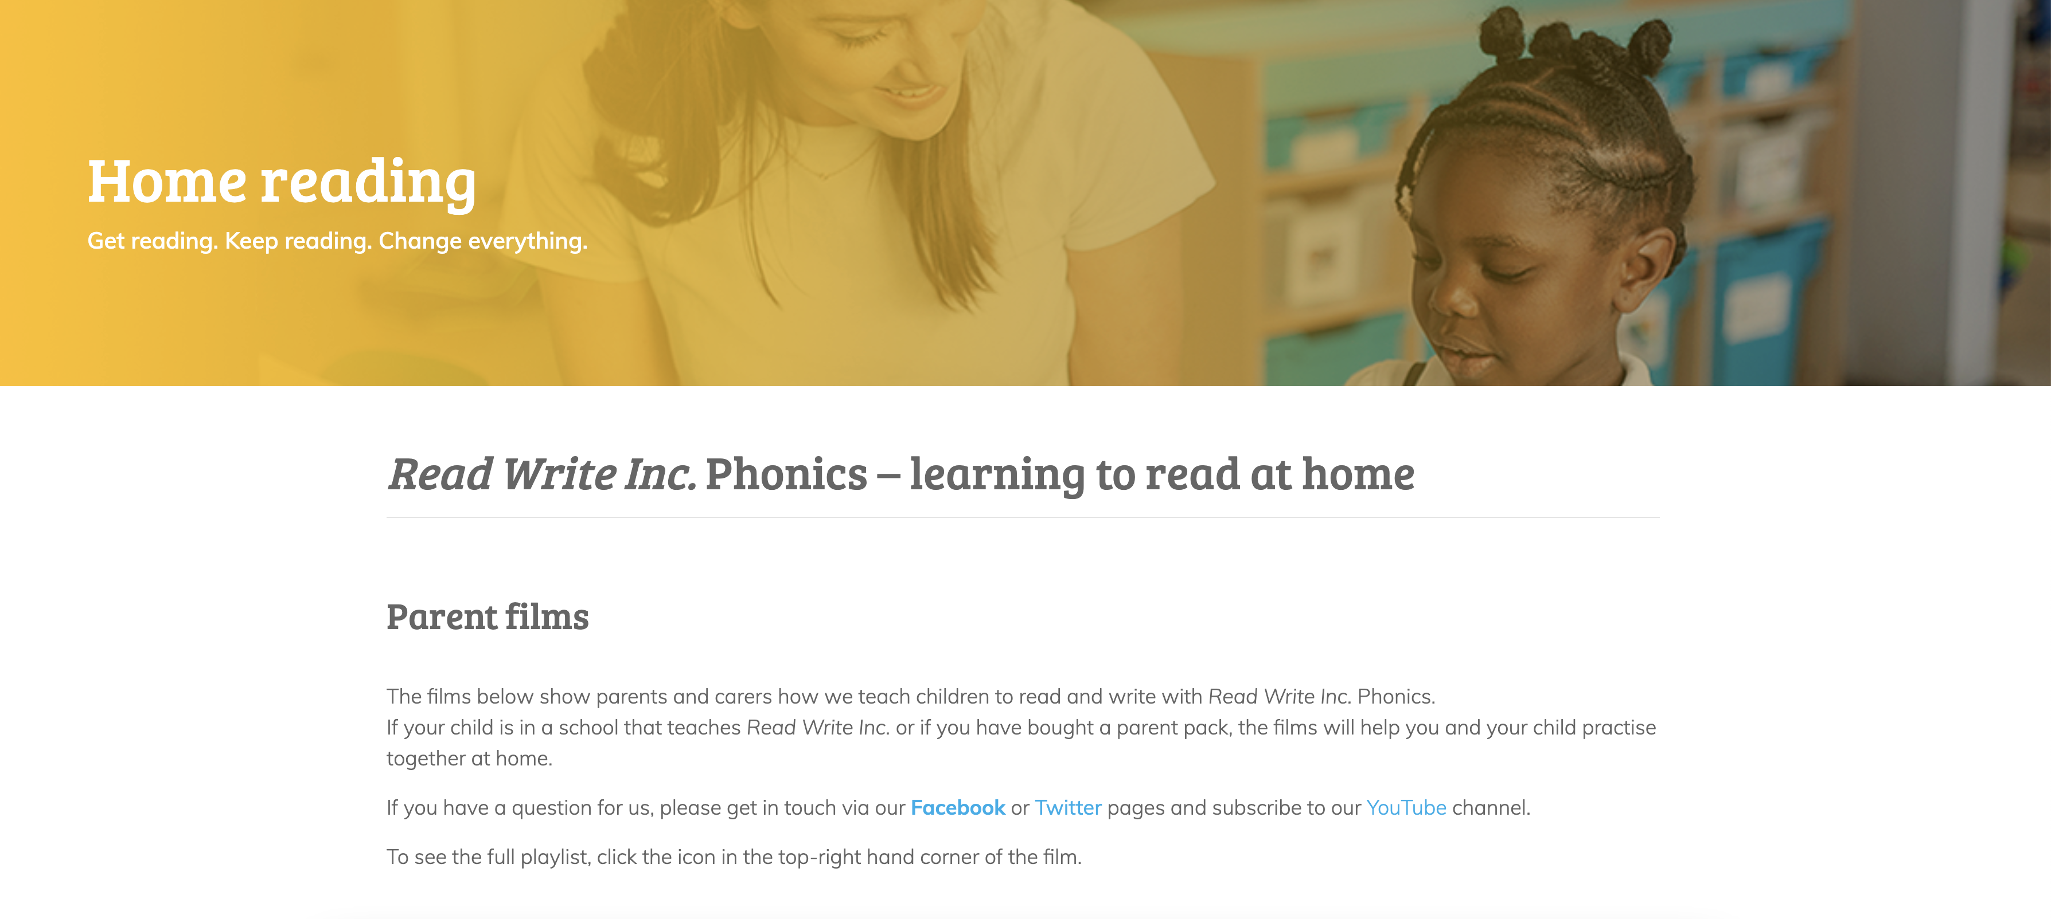

We’re also on Facebook – www.facebook.com/miskin.education

Free e-books for home reading:
http://www.oxfordowl.co.uk/Reading/

